Commands

Remember To Put space after every :

Name:mayur 🡨 Error

Name: mayur 🡨 Correct

k exec webapp -- cat /log/app.log

Execute Linux command on pod

see – is separator space before and after –

K replace --force -f new-def.yaml

Force replace POD

k get pod webapp -o yaml> poddef.yaml

Export Current Definition to Yaml

kubectl run nginx --image=nginx --dry-run=client -o yaml

Generate POD Manifest YAML file (-o yaml). Don't create it(--dry-run)

K get pod webapp -o

Get definition in Yaml form

Create A NGINX Pod

kubectl run nginx --image=nginx

While Creating host path volume

Note :

**apiVersion**: v1

**kind**: Pod

**metadata**:

**name**: test-pd

**spec**:

**containers**:

- **image**: registry.k8s.io/test-webserver

**name**: test-container

**volumeMounts**:

- **mountPath**: /test-pd

**name**: test-volume

**volumes**:

- **name**: test-volume

**hostPath**:

*# directory location on host*

**path**: /data

*# this field is optional*

**type**: Directory

k get po -A

get Pods from all Name space

k create ns ingress-space

Create New namespace

How many images are there in host

Docker images

Build using docker file, go to directory and execute below.

docker build -t webapp-color .

docker run -p 8282:8080 webapp-color

Since the kube-apiserver is running as pod you can check the process to see enabled and disabled plugins.

ps -ef | grep kube-apiserver | grep admission-plugins

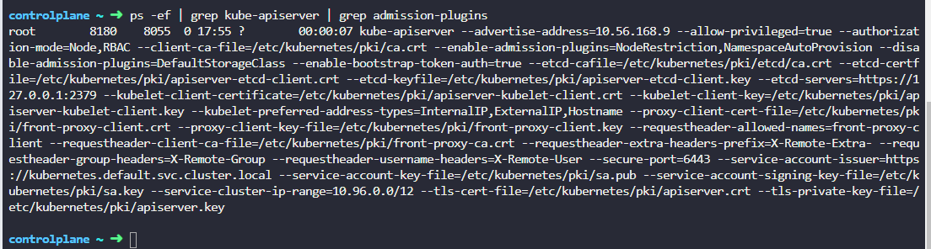

Run the command cat /etc/*release* and identify the name of the operating system.